**Web Application Development [ asp.net using c#] – Lab Manual Solutions**

**MCA/MScIT Sem-3 , 2024-25**

# **Lab Ex.1**

**Create a web application to display "Welcome to the world of ASP.NET" on web browser when user "Click" button is clicked.**

<%@ Page Language="C#" AutoEventWireup="true" CodeBehind="WebForm1.aspx.cs" Inherits="Lab_1.WebForm1" %>

<!DOCTYPE html>

<html xmlns="http://www.w3.org/1999/xhtml">

<head runat="server">

<title></title>

</head>

<body>

<form id="form1" runat="server">

<div>

<asp:Button id="btn1" runat="server" Text="Click me" onclick="btn1_Click" />

</div>

</form>

</body>

</html>

using System;

using System.Collections.Generic;

using System.Linq;

using System.Web;

using System.Web.UI;

using System.Web.UI.WebControls;

namespace Lab_1

{

public partial class WebForm1 : System.Web.UI.Page

{

protected void Page_Load(object sender, EventArgs e)

{

}

protected void btn1_Click(object sender, EventArgs e)

{

Response.Write("Welcome to the world of ASP.NET");

}

}

}

**Output:**

**Clickme**

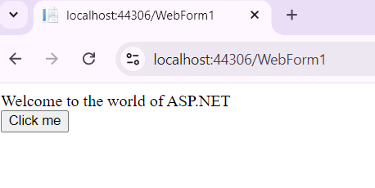

---------------------- ---------------------------- -------------

**Lab Ex.2**

**Create a web page in which user can enter enrollment no, student name and marks of 5 subjects. Calculate total, percentage and grade of student and display it. [Use text box, label, button control].**

<%@ Page Language="C#" AutoEventWireup="true" CodeBehind="WebForm1.aspx.cs" Inherits="Lab_2.WebForm1" %>

<!DOCTYPE html>

<html xmlns="http://www.w3.org/1999/xhtml">

<head runat="server">

<title></title>

</head>

<body>

<form id="form1" runat="server">

<div>

<asp:Label ID="Label1" runat="server" Text="Enrollment No."></asp:Label>

<asp:TextBox ID="fEnroll" runat="server"></asp:TextBox>

</div>

<div>

<asp:Label ID="Label2" runat="server" Text="Student Name"></asp:Label>

<asp:TextBox ID="fStudent" runat="server"></asp:TextBox>

</div>

<div>

<asp:Label ID="Label3" runat="server" Text="Subject1"></asp:Label>

<asp:TextBox ID="fSubj1" runat="server"></asp:TextBox>

</div>

<div>

<asp:Label ID="Label4" runat="server" Text="Subject2"></asp:Label>

<asp:TextBox ID="fSubj2" runat="server"></asp:TextBox>

</div>

<div>

<asp:Label ID="Label5" runat="server" Text="Subject3"></asp:Label>

<asp:TextBox ID="fSubj3" runat="server"></asp:TextBox>

</div>

<div>

<asp:Label ID="Label6" runat="server" Text="Subject4"></asp:Label>

<asp:TextBox ID="fSubj4" runat="server"></asp:TextBox>

</div>

<div>

<asp:Label ID="Label7" runat="server" Text="Subject5"></asp:Label>

<asp:TextBox ID="fSubj5" runat="server"></asp:TextBox>

</div>

<div>

<asp:Button ID="Button1" runat="server" Text="Result" onclick="Button1_Click"

/>

</div>

<div>

<asp:Label ID="fTotal" runat="server" Text="Label"></asp:Label><br />

<asp:Label ID="fAvg" runat="server" Text="Label"></asp:Label><br />

<asp:Label ID="fGrade" runat="server" Text="Label"></asp:Label>

</div>

</form>

</body>

</html>

using System;

using System.Collections.Generic;

using System.Linq;

using System.Web;

using System.Web.UI;

using System.Web.UI.WebControls;

namespace Lab_2

{

public partial class WebForm1 : System.Web.UI.Page

{

protected void Page_Load(object sender, EventArgs e)

{

}

protected void Button1_Click(object sender, EventArgs e)

{

int s1, s2, s3, s4, s5, totalMarks;

s1 = Int32.Parse(fSubj1.Text);

s2 = Int32.Parse(fSubj2.Text);

s3 = Int32.Parse(fSubj3.Text);

s4 = Int32.Parse(fSubj4.Text);

s5 = Int32.Parse(fSubj5.Text);

totalMarks = s1 + s2 + s3 + s4 + s5;

double percentage = (totalMarks / 5.0);

string grade = string.Empty;

if (percentage >= 90)

grade = "A+";

else if (percentage >= 80)

grade = "A";

else if (percentage >= 70)

grade = "B";

else if (percentage >= 60)

grade = "C";

else if (percentage >= 50)

grade = "D";

else

grade = "F";

fTotal.Text = "Total: " + totalMarks.ToString();

fAvg.Text = "Percentage: " + percentage.ToString();

fGrade.Text = "Grade: " + grade.ToString();

}

}

}

**Output:**

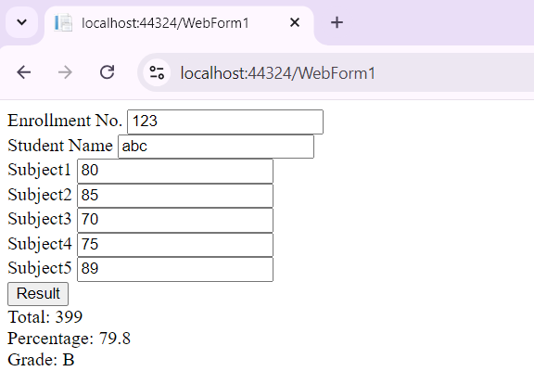

--------------------------------------- ---------------------------------------------------- ------------------------------

# **Lab Ex.3**

**Write a program to enable - disable textbox and change width of text box programmatically.**

|  |
| --- |
| <%  %> |

@ Page Language="C#" AutoEventWireup="true" CodeFile="Lab3.aspx.cs" Inherits="Lab3"

<!DOCTYPE html PUBLIC "-//W3C//DTD XHTML 1.0 Transitional//EN"

"http://www.w3.org/TR/xhtml1/DTD/xhtml1-transitional.dtd">

<html xmlns="http://www.w3.org/1999/xhtml">

<head runat="server">

<title></title>

</head>

<body>

<form id="form1" runat="server">

<div>

<asp:TextBox ID="txtDynamic" runat="server"></asp:TextBox>

<asp:Button ID="btnToggle" runat="server" Text="Toggle Enable/Disable" OnClick="btnToggle_Click" />

<asp:Button ID="btnChangeWidth" runat="server" Text="Change Width"

OnClick="btnChangeWidth_Click" />

</div>

</form>

</body>

</html>

using System;

using System.Collections.Generic; using System.Linq; using System.Web; using System.Web.UI;

using System.Web.UI.WebControls;

public partial class Lab3 : System.Web.UI.Page

{

protected void Page_Load(object sender, EventArgs e)

{

if (!IsPostBack)

{

txtDynamic.Enabled = true; txtDynamic.Width = new Unit(200);

} }

protected void btnToggle_Click(object sender, EventArgs e)

{

txtDynamic.Enabled = !txtDynamic.Enabled;

}

protected void btnChangeWidth_Click(object sender, EventArgs e)

{

txtDynamic.Width = new Unit(txtDynamic.Width.Value + 50);

}

}

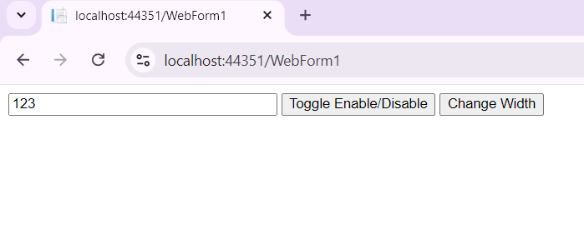

## Lab Ex.4

**Create a web page that will take two radio buttons labeled as a gender, if user selects radio button the gender will be changed according to selected radio button.**

|  |
| --- |
| <%  %> |

@ Page Language="C#" AutoEventWireup="true" CodeFile="Lab4.aspx.cs" Inherits="Lab4"

<!DOCTYPE html PUBLIC "-//W3C//DTD XHTML 1.0 Transitional//EN"

"http://www.w3.org/TR/xhtml1/DTD/xhtml1-transitional.dtd">

<html xmlns="http://www.w3.org/1999/xhtml">

<head runat="server">

<title></title>

</head>

<body>

<form id="form1" runat="server">

<div>

<asp:Label ID="Label1" runat="server" Text="Gender"></asp:Label>

<asp:RadioButton ID="fMale" runat="server" Text="Male" GroupName="gender" /> <asp:RadioButton ID="fFemale" runat="server" Text="Female" GroupName="gender"

/>

</div>

<div> <asp:Button ID="Button1" runat="server" Text="Submit" onclick="Button1_Click"

/></div>

</form>

</body>

</html> using System;

using System.Collections.Generic; using System.Linq; using System.Web; using System.Web.UI;

using System.Web.UI.WebControls;

public partial class Lab4 : System.Web.UI.Page

{

protected void Page_Load(object sender, EventArgs e)

{

}

protected void Button1_Click(object sender, EventArgs e)

{

if (fMale.Checked == true) Response.Write("Male Checked"); if (fFemale.Checked == true) Response.Write("Female Checked"); }

}

Output:

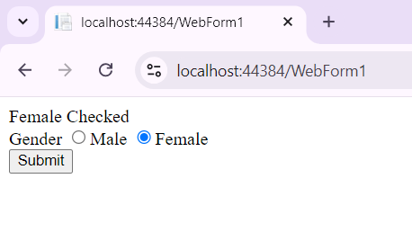

----------------------------- ----------------------------------------- -------------------------------------------

## Lab Ex.5

**Write a program which have list box and image controls, list box is used to display items and when user clicks on item in list box it display the item image in image control.**

|  |
| --- |
| <%  %> |

@ Page Language="C#" AutoEventWireup="true" CodeFile="Lab5.aspx.cs" Inherits="Lab5"

<!DOCTYPE html PUBLIC "-//W3C//DTD XHTML 1.0 Transitional//EN"

"http://www.w3.org/TR/xhtml1/DTD/xhtml1-transitional.dtd">

<html xmlns="http://www.w3.org/1999/xhtml">

<head runat="server">

<title></title>

</head>

<body>

<form id="form1" runat="server">

<div>

<asp:ListBox ID="ListBox1" runat="server" AutoPostBack="True"

OnSelectedIndexChanged="ListBox1_SelectedIndexChanged">

<asp:ListItem Text="Select an item..." Value="0"></asp:ListItem>

<asp:ListItem Text="Google" Value="1"></asp:ListItem>

<asp:ListItem Text="Edge" Value="2"></asp:ListItem>

<asp:ListItem Text="Browser" Value="3"></asp:ListItem>

</asp:ListBox>

<br />

<asp:Image ID="fImage" runat="server" Height="200px" Width="200px" />

</div>

</form>

</body>

</html>

using System;

using System.Collections.Generic; using System.Linq;

using System.Web;

using System.Web.UI;

using System.Web.UI.WebControls;

public partial class Lab5 : System.Web.UI.Page

{

protected void Page_Load(object sender, EventArgs e)

{

if (!IsPostBack)

{

DisplayImageForSelectedItem();

} }

protected void ListBox1_SelectedIndexChanged(object sender, EventArgs e) {

DisplayImageForSelectedItem();

}

private void DisplayImageForSelectedItem()

{

// Map selected index to image URL string[] images = {

"", // Index 0 (no item selected)

"~/Images/1.jpg", // Index 1 (Item 1)

"~/Images/2.jpg", // Index 2 (Item 2)

"~/Images/3.jpg" // Index 3 (Item 3)

};

int selectedIndex = ListBox1.SelectedIndex;

if (selectedIndex >= 0 && selectedIndex < images.Length)

{

fImage.ImageUrl = images[selectedIndex];

} else {

fImage.ImageUrl = "";

}

}

}

---------------------- ------------------------------------------------- ------------------------------- -------------------------

## Lab Ex.6

**Create a web page for registration which have name, dob, gender, email id, contact no, address, city, pin code, hobbies and display all data in same page with proper layout.**

|  |
| --- |
| <%  %> |

@ Page Language="C#" AutoEventWireup="true" CodeFile="Lab6.aspx.cs" Inherits="Lab6"

<!DOCTYPE html PUBLIC "-//W3C//DTD XHTML 1.0 Transitional//EN"

"http://www.w3.org/TR/xhtml1/DTD/xhtml1-transitional.dtd">

<html xmlns="http://www.w3.org/1999/xhtml">

<head runat="server">

<title></title>

</head>

<body>

<form id="form1" runat="server">

<div>

<asp:Label ID="Label1" runat="server" Text="Student Name"></asp:Label>

<asp:TextBox ID="fName" runat="server"></asp:TextBox>

</div>

<div>

<asp:Label ID="Label2" runat="server" Text="Date of Birth"></asp:Label>

<asp:TextBox ID="fDob" runat="server"></asp:TextBox>

</div>

<div>

<asp:Label ID="Label3" runat="server" Text="Gender"></asp:Label>

<asp:RadioButton ID="fMale" runat="server" Text="Male" GroupName="gender"

Checked="true" />

<asp:RadioButton ID="fFemale" runat="server" Text="Female"

GroupName="gender" />

</div>

<div>

<asp:Label ID="Label4" runat="server" Text="Email"></asp:Label>

<asp:TextBox ID="fEmail" runat="server"></asp:TextBox>

</div>

<div>

<asp:Label ID="Label5" runat="server" Text="Contact"></asp:Label>

<asp:TextBox ID="fContact" runat="server"></asp:TextBox>

</div>

<div>

<asp:Label ID="Label6" runat="server" Text="Address"></asp:Label>

<asp:TextBox ID="fAddress" runat="server"></asp:TextBox>

</div>

<div>

<asp:Label ID="Label7" runat="server" Text="City"></asp:Label>

<asp:DropDownList ID="fCity" runat="server">

<asp:ListItem>Vadodara</asp:ListItem>

<asp:ListItem>Surat</asp:ListItem>

<asp:ListItem>Anand</asp:ListItem>

<asp:ListItem>Nadidad</asp:ListItem>

</asp:DropDownList>

</div>

<div>

<asp:Label ID="Label8" runat="server" Text="Pincode"></asp:Label>

<asp:TextBox ID="fPincode" runat="server"></asp:TextBox>

</div>

<div>

<asp:Label ID="Label9" runat="server" Text="Hobbies"></asp:Label>

<asp:CheckBox ID="CheckBox1" runat="server" Text="Singing" /><br />

<asp:CheckBox ID="CheckBox2" runat="server" Text="Dancing" /><br />

<asp:CheckBox ID="CheckBox3" runat="server" Text="Painting" /><br />

<asp:CheckBox ID="CheckBox4" runat="server" Text="Sports" />

</div>

<div>

<asp:Button ID="fRegisterBtn" runat="server" Text="REGISTER" onclick="fRegisterBtn_Click" />

</div>

<br /><hr />

<center>

<br />

<div id="output" runat="server" visible="false">

<h2>Registration Details</h2>

<p><strong>Name:</strong> <asp:Label ID="lblName" runat="server"></asp:Label></p>

<p><strong>Date of Birth:</strong> <asp:Label ID="lblDOB" runat="server"></asp:Label></p>

<p><strong>Gender:</strong> <asp:Label ID="lblGender" runat="server"></asp:Label></p>

<p><strong>Email ID:</strong> <asp:Label ID="lblEmail" runat="server"></asp:Label></p>

<p><strong>Contact No:</strong> <asp:Label ID="lblContactNo" runat="server"></asp:Label></p>

<p><strong>Address:</strong> <asp:Label ID="lblAddress" runat="server"></asp:Label></p>

<p><strong>City:</strong> <asp:Label ID="lblCity" runat="server"></asp:Label></p>

<p><strong>Pin Code:</strong> <asp:Label ID="lblPinCode" runat="server"></asp:Label></p>

<p><strong>Hobbies:</strong> <asp:Label ID="lblHobbies" runat="server"></asp:Label></p>

</div>

</center>

</form>

</body>

</html> using System;

using System.Collections.Generic; using System.Linq; using System.Web; using System.Web.UI;

using System.Web.UI.WebControls;

public partial class Lab6 : System.Web.UI.Page

{

protected void Page_Load(object sender, EventArgs e)

{

if (IsPostBack == true) return;

}

protected void fRegisterBtn_Click(object sender, EventArgs e)

{

String name, dob, gender, email, contactNo, address, city, pinCode; name = fName.Text; if (fMale.Checked == true) gender = "Male"; else

gender = "Female"; dob = fDob.Text; email = fEmail.Text; contactNo = fContact.Text; address = fAddress.Text; city = fCity.SelectedItem.ToString(); pinCode = fPincode.Text;

string strCheckValue = ""; if (CheckBox1.Checked)

{

strCheckValue = strCheckValue + "," + CheckBox1.Text;

}

if (CheckBox2.Checked)

{

strCheckValue = strCheckValue + "," + CheckBox2.Text;

}

if (CheckBox3.Checked)

{

strCheckValue = strCheckValue + "," + CheckBox3.Text;

}

if (CheckBox4.Checked)

{

strCheckValue = strCheckValue + "," + CheckBox4.Text;

} lblName.Text = name; lblDOB.Text = dob; lblGender.Text = gender; lblEmail.Text = email; lblContactNo.Text = contactNo; lblAddress.Text = address; lblCity.Text = city; lblPinCode.Text = pinCode; lblHobbies.Text = strCheckValue; output.Visible = true;

} }

**Output:**

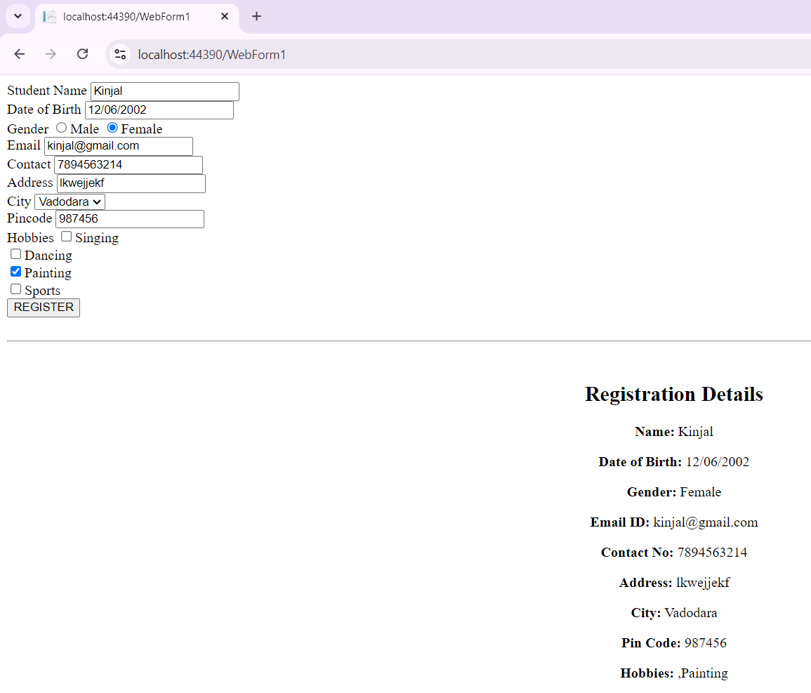

# ------------ ---------------- ---------------------

## Lab Ex.7

**Write a program that uses a textbox for a user input and validate it using required field validation**.

[Please see solution of Lab Ex. 8 for validation]

--------------------------- ---------------------------------------------------------------- ---------------------------

## Lab Ex.8

**Create a web page for registration which have name, dob, gender, email id, contact no, address, city, pin code, hobbies. After the user enters the appropriate values the validate button must validates the values entered and display all data in same page with proper layout.**

<%@ Page Language="C#" AutoEventWireup="true" CodeFile="Lab7_And_8.aspx.cs"

Inherits="Lab7_And_8" %>

<!DOCTYPE html PUBLIC "-//W3C//DTD XHTML 1.0 Transitional//EN"

"http://www.w3.org/TR/xhtml1/DTD/xhtml1-transitional.dtd">

<html xmlns="http://www.w3.org/1999/xhtml">

<head runat="server">

<title></title>

</head>

<body>

<form id="form1" runat="server">

<div>

<asp:Label ID="Label1" runat="server" Text="Student Name"></asp:Label>

<asp:TextBox ID="fName" runat="server"></asp:TextBox>

<asp:RequiredFieldValidator ID="RFV1" runat="server"

ErrorMessage="Name Required" ForeColor="Red"

ControlToValidate="fName"></asp:RequiredFieldValidator>

</div>

<div>

<asp:Label ID="Label2" runat="server" Text="Date of Birth"></asp:Label>

<asp:TextBox ID="fDob" runat="server"></asp:TextBox>

<asp:CompareValidator ID="CompareValidator2" runat="server"

ErrorMessage="Invalid Date" ControlToValidate="fDob"

Operator="DataTypeCheck" Type="Date"></asp:CompareValidator>

</div>

<div>

<asp:Label ID="Label3" runat="server" Text="Gender"></asp:Label>

<asp:RadioButton ID="fMale" runat="server" Text="Male" GroupName="gender"

Checked="true" />

<asp:RadioButton ID="fFemale" runat="server" Text="Female"

GroupName="gender" />

</div>

<div>

<asp:Label ID="Label4" runat="server" Text="Email"></asp:Label>

<asp:TextBox ID="fEmail" runat="server"></asp:TextBox>

<asp:RegularExpressionValidator ID="REV1" runat="server"

ErrorMessage="Invalid Format" ControlToValidate="fEmail"

ValidationExpression="\w+([-+.']\w+)*@\w+([-.]\w+)*\.\w+([-

.]\w+)*"></asp:RegularExpressionValidator>

</div>

<div>

<asp:Label ID="Label5" runat="server" Text="Contact"></asp:Label>

<asp:TextBox ID="fContact" runat="server"></asp:TextBox>

</div>

<div>

<asp:Label ID="Label6" runat="server" Text="Address"></asp:Label>

<asp:TextBox ID="fAddress" runat="server"></asp:TextBox>

<asp:RequiredFieldValidator ID="RequiredFieldValidator1" runat="server"

ControlToValidate="fAddress" ErrorMessage="Address

Required"></asp:RequiredFieldValidator>

</div>

<div>

<asp:Label ID="Label7" runat="server" Text="City"></asp:Label>

<asp:DropDownList ID="fCity" runat="server">

<asp:ListItem>Vadodara</asp:ListItem>

<asp:ListItem>Surat</asp:ListItem>

<asp:ListItem>Anand</asp:ListItem>

<asp:ListItem>Nadidad</asp:ListItem>

</asp:DropDownList>

</div>

<div>

<asp:Label ID="Label8" runat="server" Text="Pincode"></asp:Label>

<asp:TextBox ID="fPincode" runat="server"></asp:TextBox>

<asp:RegularExpressionValidator ID="RegularExpressionValidator1" runat="server"

ErrorMessage="Invalid Format" ControlToValidate="fPincode" ValidationExpression="\d{6}"></asp:RegularExpressionValidator>

</div>

<div>

<asp:Label ID="Label9" runat="server" Text="Hobbies"></asp:Label>

<asp:CheckBox ID="CheckBox1" runat="server" Text="Singing" /><br />

<asp:CheckBox ID="CheckBox2" runat="server" Text="Dancing" /><br />

<asp:CheckBox ID="CheckBox3" runat="server" Text="Painting" /><br />

<asp:CheckBox ID="CheckBox4" runat="server" Text="Sports" />

</div>

<div>

<asp:Button ID="fRegisterBtn" runat="server" Text="REGISTER" onclick="fRegisterBtn_Click" />

</div>

<br /><hr />

<center>

<br />

<div id="output" runat="server" visible="false">

<h2>Registration Details</h2>

<p><strong>Name:</strong> <asp:Label ID="lblName" runat="server"></asp:Label></p>

<p><strong>Date of Birth:</strong> <asp:Label ID="lblDOB" runat="server"></asp:Label></p>

<p><strong>Gender:</strong> <asp:Label ID="lblGender" runat="server"></asp:Label></p>

<p><strong>Email ID:</strong> <asp:Label ID="lblEmail" runat="server"></asp:Label></p>

<p><strong>Contact No:</strong> <asp:Label ID="lblContactNo" runat="server"></asp:Label></p>

<p><strong>Address:</strong> <asp:Label ID="lblAddress" runat="server"></asp:Label></p>

<p><strong>City:</strong> <asp:Label ID="lblCity" runat="server"></asp:Label></p>

<p><strong>Pin Code:</strong> <asp:Label ID="lblPinCode" runat="server"></asp:Label></p>

<p><strong>Hobbies:</strong> <asp:Label ID="lblHobbies" runat="server"></asp:Label></p>

</div>

</center>

</form>

</body>

</html> using System;

using System.Collections.Generic; using System.Linq; using System.Web; using System.Web.UI;

using System.Web.UI.WebControls;

public partial class Lab7_And_8 : System.Web.UI.Page

{

protected void Page_Load(object sender, EventArgs e) {

if (IsPostBack == true) return;

}

protected void fRegisterBtn_Click(object sender, EventArgs e)

{

String name, dob, gender, email, contactNo, address, city, pinCode; name = fName.Text; if (fMale.Checked == true) gender = "Male"; else

gender = "Female"; dob = fDob.Text; email = fEmail.Text; contactNo = fContact.Text; address = fAddress.Text; city = fCity.SelectedItem.ToString(); pinCode = fPincode.Text;

string strCheckValue = ""; if (CheckBox1.Checked)

{

strCheckValue = strCheckValue + "," + CheckBox1.Text;

}

if (CheckBox2.Checked)

{

strCheckValue = strCheckValue + "," + CheckBox2.Text;

}

if (CheckBox3.Checked)

{

strCheckValue = strCheckValue + "," + CheckBox3.Text;

}

if (CheckBox4.Checked)

{

strCheckValue = strCheckValue + "," + CheckBox4.Text;

} lblName.Text = name; lblDOB.Text = dob; lblGender.Text = gender; lblEmail.Text = email; lblContactNo.Text = contactNo; lblAddress.Text = address; lblCity.Text = city; lblPinCode.Text = pinCode; lblHobbies.Text = strCheckValue; output.Visible = true;

} }

------------------------------- --------------------------- ------------------ **Lab Ex.9**

**Write a program to check the length of the string in the text box using custom validation**.

|  |
| --- |
| <%  %> |

@ Page Language="C#" AutoEventWireup="true" CodeFile="Lab9.aspx.cs" Inherits="Lab9"

<!DOCTYPE html PUBLIC "-//W3C//DTD XHTML 1.0 Transitional//EN"

"http://www.w3.org/TR/xhtml1/DTD/xhtml1-transitional.dtd">

<html xmlns="http://www.w3.org/1999/xhtml">

<head runat="server">

<title></title>

<script type="text/javascript">

function validateStringLength(sender, args) { var maxLength = 50;

var inputValue = args.Value.trim();

args.IsValid = (inputValue.length <= maxLength);

}

</script>

</head>

<body>

<form id="form1" runat="server">

<div>

Enter any string :

<asp:TextBox ID="TextBox1" runat="server"></asp:TextBox>

<asp:CustomValidator ID="CustomValidator1" runat="server"

ControlToValidate="TextBox1"

ErrorMessage="String length must be less than 50 characters"

ClientValidationFunction="validateStringLength"></asp:CustomValidator>

</div>

<div>

<asp:Button ID="Button1" runat="server" Text="Submit" />

</div>

</form>

</body>

</html>

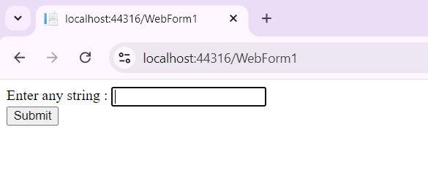

-------------------------------- ----------------------------------- -------------- **Lab Ex.10**

**Create a master page that contain links for home page, about us page and contact page, when user clicks on particular link it will display that particular page.**

Step:1 Add a master page [ for ex. MasterPage.master]

Step:2 Now and three content pages as – Home.aspx, About.aspx, Contact.aspx

**MasterPage.master**

<%@ Master Language="C#" AutoEventWireup="true" CodeFile="MasterPage.master.cs"

Inherits="MasterPage" %>

<!DOCTYPE html PUBLIC "-//W3C//DTD XHTML 1.0 Transitional//EN"

"http://www.w3.org/TR/xhtml1/DTD/xhtml1-transitional.dtd">

<html xmlns="http://www.w3.org/1999/xhtml">

<head runat="server">

<title></title>

<asp:ContentPlaceHolder id="head" runat="server">

</asp:ContentPlaceHolder>

</head>

<body>

<form id="form1" runat="server">

<div>

<header>

<h1>Welcome to My Site</h1>

<nav>

<ul>

<li><asp:HyperLink ID="HyperLink1" runat="server" NavigateUrl="~/Home.aspx">Home</asp:HyperLink></li>

<li><asp:HyperLink ID="HyperLink2" runat="server"

NavigateUrl="~/About.aspx">AboutUs</asp:HyperLink></li>

<li><asp:HyperLink ID="HyperLink3" runat="server"

NavigateUrl="~/Contact.aspx">ContactUs</asp:HyperLink></li>

</ul>

</nav>

</header>

<asp:ContentPlaceHolder id="ContentPlaceHolder1" runat="server">

</asp:ContentPlaceHolder>

</div>

</form>

</body>

</html>

### Home.aspx

<%@ Page Title="" Language="C#" MasterPageFile="~/MasterPage.master"

AutoEventWireup="true" CodeFile="Home.aspx.cs" Inherits="_Default" %>

<asp:Content ID="Content1" ContentPlaceHolderID="head" Runat="Server">

</asp:Content>

<asp:Content ID="Content2" ContentPlaceHolderID="ContentPlaceHolder1" Runat="Server">

Welcome to Home Page

</asp:Content>

### About.aspx

<%@ Page Title="" Language="C#" MasterPageFile="~/MasterPage.master"

AutoEventWireup="true" CodeFile="About.aspx.cs" Inherits="_Default" %>

<asp:Content ID="Content1" ContentPlaceHolderID="head" Runat="Server">

</asp:Content>

<asp:Content ID="Content2" ContentPlaceHolderID="ContentPlaceHolder1" Runat="Server">

We are professional in website development

</asp:Content>

### Contact.aspx

<%@ Page Title="" Language="C#" MasterPageFile="~/MasterPage.master"

AutoEventWireup="true" CodeFile="Contact.aspx.cs" Inherits="_Default" %>

<asp:Content ID="Content1" ContentPlaceHolderID="head" Runat="Server">

</asp:Content>

<asp:Content ID="Content2" ContentPlaceHolderID="ContentPlaceHolder1" Runat="Server">

Call us : 9229891004

</asp:Content>

**[OR]**

<!DOCTYPE html>

<html lang="en">

<head>

<meta charset="UTF-8">

<meta name="viewport" content="width=device-width, initial-scale=1.0">

<title>Master Page Example</title>

<style>

body {

font-family: Arial, sans-serif;

}

.nav {

margin-bottom: 20px;

}

.nav a {

margin-right: 10px;

text-decoration: none;

color: blue;

}

.nav a:hover {

text-decoration: underline;

}

.content {

display: none;

}

.active {

display: block;

}

</style>

</head>

<body>

<div class="nav">

<a href="#" onclick="showPage('home')">Home</a>

<a href="#" onclick="showPage('about')">About Us</a>

<a href="#" onclick="showPage('contact')">Contact</a>

</div>

<div id="home" class="content active">

<h1>Home Page</h1>

<p>Welcome to our home page!</p>

</div>

<div id="about" class="content">

<h1>About Us</h1>

<p>Learn more about us on this page.</p>

</div>

<div id="contact" class="content">

<h1>Contact</h1>

<p>Get in touch with us through this page.</p>

</div>

<script>

function showPage(pageId) {

var pages = document.querySelectorAll('.content');

pages.forEach(function(page) {

page.classList.remove('active');

});

document.getElementById(pageId).classList.add('active');

}

</script>

</body>

</html>

Output:

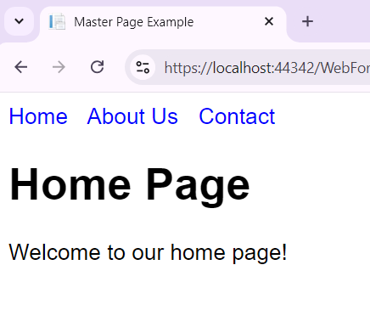

# ------------------- ----------------- --------------

**Lab Ex.11**

**1) index . html**

<!DOCTYPE html>

<html lang="en">

<head>

<meta charset="UTF-8">

<meta name="viewport" content="width=device-width, initial-scale=1.0">

<title>Registration System</title>

<link rel="stylesheet" href="style.css">

</head>

<body>

<div class="nav">

<a href="index.html">Home</a>

<a href="register.html">Register</a>

<a href="login.html">Login</a>

</div>

<div id="content">

<h1>Welcome to the Registration System</h1>

<p>Please use the navigation links to register or login.</p>

</div>

</body>

</html>

**2) register . html**

<!DOCTYPE html>

<html lang="en">

<head>

<meta charset="UTF-8">

<meta name="viewport" content="width=device-width, initial-scale=1.0">

<title>Register</title>

<link rel="stylesheet" href="style.css">

</head>

<body>

<div class="nav">

<a href="index.html">Home</a>

<a href="register.html">Register</a>

<a href="login.html">Login</a>

</div>

<div id="content">

<h1>Register</h1>

<form action="auth.php" method="post">

<input type="hidden" name="action" value="register">

<label for="username">Username:</label>

<input type="text" id="username" name="username" required><br><br>

<label for="password">Password:</label>

<input type="password" id="password" name="password" required><br><br>

<button type="submit">Register</button>

</form>

</div>

</body>

</html>

**3) login . html**

<!DOCTYPE html>

<html lang="en">

<head>

<meta charset="UTF-8">

<meta name="viewport" content="width=device-width, initial-scale=1.0">

<title>Login</title>

<link rel="stylesheet" href="style.css">

</head>

<body>

<div class="nav">

<a href="index.html">Home</a>

<a href="register.html">Register</a>

<a href="login.html">Login</a>

</div>

<div id="content">

<h1>Login</h1>

<form action="auth.php" method="post">

<input type="hidden" name="action" value="login">

<label for="username">Username:</label>

<input type="text" id="username" name="username" required><br><br>

<label for="password">Password:</label>

<input type="password" id="password" name="password" required><br><br>

<button type="submit">Login</button>

</form>

</div>

</body>

</html>

**4) dashboard . html**

<!DOCTYPE html>

<html lang="en">

<head>

<meta charset="UTF-8">

<meta name="viewport" content="width=device-width, initial-scale=1.0">

<title>Dashboard</title>

<link rel="stylesheet" href="style.css">

</head>

<body>

<div class="nav">

<a href="index.html">Home</a>

<a href="register.html">Register</a>

<a href="login.html">Login</a>

</div>

<div id="content">

<h1>Welcome, <?php echo htmlspecialchars($_SESSION['username']); ?>!</h1>

<p>This is your dashboard.</p>

<a href="auth.php?action=logout">Logout</a>

</div>

</body>

</html>

**5) style . css**

body {

font-family: Arial, sans-serif;

}

.nav {

margin-bottom: 20px;

}

.nav a {

margin-right: 10px;

text-decoration: none;

color: blue;

}

.nav a:hover {

text-decoration: underline;

}

#content {

margin: 20px;

}

**6) script . js**

<?php

session_start();

function redirect($url) {

header("Location: $url");

exit();

}

if ($_SERVER['REQUEST_METHOD'] === 'POST') {

if ($_POST['action'] === 'register') {

// For simplicity, storing credentials in session (not recommended for production)

$_SESSION['users'][$_POST['username']] = $_POST['password'];

redirect('login.html');

} elseif ($_POST['action'] === 'login') {

if (isset($_SESSION['users'][$_POST['username']]) && $_SESSION['users'][$_POST['username']] === $_POST['password']) {

$_SESSION['username'] = $_POST['username'];

redirect('dashboard.html');

} else {

echo "Invalid login credentials.";

}

}

} elseif ($_GET['action'] === 'logout') {

session_destroy();

redirect('login.html');

}

?>

**[OR]**

<%@ Master Language="C#" AutoEventWireup="true" CodeBehind="Site1.master.cs" Inherits="Lab_11.Site1" %>

<!DOCTYPE html>

<html>

<head runat="server">

<title></title>

<asp:ContentPlaceHolder ID="head" runat="server">

</asp:ContentPlaceHolder>

</head>

<body>

<form id="form1" runat="server">

<div>

<asp:HyperLink ID="HyperLink1" runat="server">HyperLink</asp:HyperLink>

<asp:ContentPlaceHolder ID="ContentPlaceHolder1" runat="server">

</asp:ContentPlaceHolder>

</div>

</form>

</body>

</html>

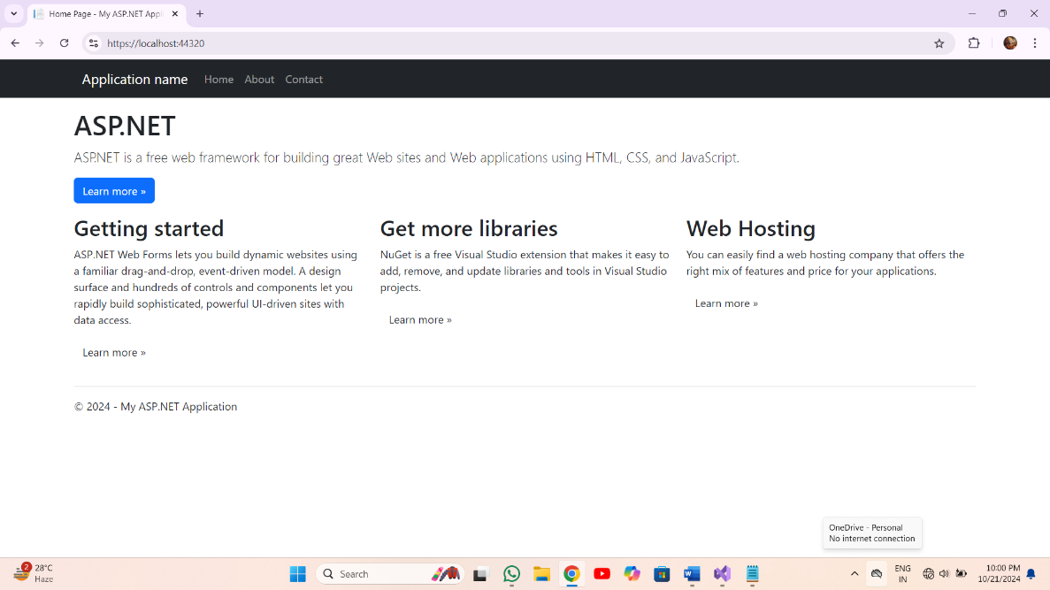

**Lab Ex.12**

**.aspx:**

<%@ Page Language="C#" AutoEventWireup="true" CodeBehind="WebForm1.aspx.cs" Inherits="Lab_12.WebForm1" %>

<!DOCTYPE html>

<html xmlns="http://www.w3.org/1999/xhtml">

<head runat="server">

<title>Persistent Cookie Example</title>

</head>

<body>

<form id="form1" runat="server">

<div>

<asp:Label ID="lblPrompt" runat="server" Text="Enter your Name:"></asp:Label>

<asp:TextBox ID="txtName" runat="server"></asp:TextBox>

<asp:Button ID="btnSubmit" runat="server" Text="Submit" OnClick="btnSubmit_Click" />

<asp:Label ID="lblMessage" runat="server" ></asp:Label>

</div>

</form>

</body>

</html>

**aspx.cs**

using System;

using System.Collections.Generic;

using System.Linq;

using System.Web;

using System.Web.UI;

using System.Web.UI.WebControls;

namespace Lab_12

{

public partial class WebForm1 : System.Web.UI.Page

{

protected void Page_Load(object sender, EventArgs e)

{

if (!IsPostBack)

{

HttpCookie cookie = Request.Cookies["UserName"];

if (cookie != null)

{

string userName = cookie.Value;

lblMessage.Text = "Welcome back," + userName + "!";

}

}

}

protected void btnSubmit_Click(object sender, EventArgs e)

{

string userName = txtName.Text;

if (!string.IsNullOrEmpty(userName))

{

HttpCookie cookie = new HttpCookie(userName);

cookie.Value = userName;

cookie.Expires = DateTime.Now.AddYears(1);

Response.Cookies.Add(cookie);

lblMessage.Text = "Name saved! Welcome," + userName + "!";

}

else

{

lblMessage.Text = "Please Enter Your Name:";

}

}

}

}

**Output:**

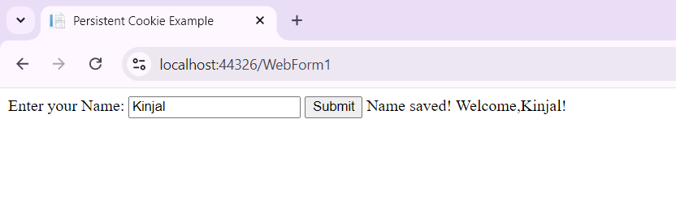

**13.Database CRUD operations [Gridview] Create student database which contain table stud_registration and have fields like first name, last name, dob, email id, contact number, gender, address, city, pin code. Create web application which will insert, view, search, update, and delete records from stud_registration table. [Use gridview]**

1) database setup:-

-------------------

CREATE DATABASE student_db;

USE student_db;

CREATE TABLE stud_registration (

id INT AUTO_INCREMENT PRIMARY KEY,

first_name VARCHAR(50),

last_name VARCHAR(50),

dob DATE,

email_id VARCHAR(100),

contact_number VARCHAR(15),

gender ENUM('Male', 'Female', 'Other'),

address TEXT,

city VARCHAR(50),

pin_code VARCHAR(10)

);

2) index . html:-

------------------

<!DOCTYPE html>

<html>

<head>

<title>Student Registration</title>

<link rel="stylesheet" type="text/css" href="style.css">

</head>

<body>

<h1>Student Registration</h1>

<form id="studentForm" method="post" action="process.php">

<label for="first_name">First Name:</label>

<input type="text" id="first_name" name="first_name" required><br>

<label for="last_name">Last Name:</label>

<input type="text" id="last_name" name="last_name" required><br>

<label for="dob">Date of Birth:</label>

<input type="date" id="dob" name="dob" required><br>

<label for="email_id">Email ID:</label>

<input type="email" id="email_id" name="email_id" required><br>

<label for="contact_number">Contact Number:</label>

<input type="text" id="contact_number" name="contact_number" required><br>

<label for="gender">Gender:</label>

<select id="gender" name="gender" required>

<option value="Male">Male</option>

<option value="Female">Female</option>

<option value="Other">Other</option>

</select><br>

<label for="address">Address:</label>

<textarea id="address" name="address" required></textarea><br>

<label for="city">City:</label>

<input type="text" id="city" name="city" required><br>

<label for="pin_code">Pin Code:</label>

<input type="text" id="pin_code" name="pin_code" required><br>

<input type="submit" value="Submit">

</form>

<h2>Student Records</h2>

<div id="gridview">

<?php include 'gridview.php'; ?>

</div>

</body>

</html>

3) style . css :-

-----------------

body {

font-family: Arial, sans-serif;

}

form {

margin-bottom: 20px;

}

label {

display: inline-block;

width: 120px;

}

input, select, textarea {

margin-bottom: 10px;

width: 200px;

}

#gridview {

margin-top: 20px;

}

table {

width: 100%;

border-collapse: collapse;

}

table, th, td {

border: 1px solid black;

}

th, td {

padding: 10px;

text-align: left;

}

4) process . php :-

-------------------

<?php

$servername = "localhost";

$username = "root";

$password = "";

$dbname = "student_db";

// Create connection

$conn = new mysqli($servername, $username, $password, $dbname);

// Check connection

if ($conn->connect_error) {

die("Connection failed: " . $conn->connect_error);

}

if ($_SERVER["REQUEST_METHOD"] == "POST") {

$first_name = $_POST['first_name'];

$last_name = $_POST['last_name'];

$dob = $_POST['dob'];

$email_id = $_POST['email_id'];

$contact_number = $_POST['contact_number'];

$gender = $_POST['gender'];

$address = $_POST['address'];

$city = $_POST['city'];

$pin_code = $_POST['pin_code'];

$sql = "INSERT INTO stud_registration (first_name, last_name, dob, email_id, contact_number, gender, address, city, pin_code)

VALUES ('$first_name', '$last_name', '$dob', '$email_id', '$contact_number', '$gender', '$address', '$city', '$pin_code')";

if ($conn->query($sql) === TRUE) {

echo "New record created successfully";

} else {

echo "Error: " . $sql . "<br>" . $conn->error;

}

}

$conn->close();

header("Location: index.html");

exit();

?>

5) gridview . php:-

-------------------

<?php

$servername = "localhost";

$username = "root";

$password = "";

$dbname = "student_db";

// Create connection

$conn = new mysqli($servername, $username, $password, $dbname);

// Check connection

if ($conn->connect_error) {

die("Connection failed: " . $conn->connect_error);

}

$sql = "SELECT * FROM stud_registration";

$result = $conn->query($sql);

if ($result->num_rows > 0) {

echo "<table><tr><th>ID</th><th>First Name</th><th>Last Name</th><th>DOB</th><th>Email</th><th>Contact</th><th>Gender</th><th>Address</th><th>City</th><th>Pin Code</th><th>Actions</th></tr>";

while($row = $result->fetch_assoc()) {

echo "<tr><td>".$row["id"]."</td><td>".$row["first_name"]."</td><td>".$row["last_name"]."</td><td>".$row["dob"]."</td><td>".$row["email_id"]."</td><td>".$row["contact_number"]."</td><td>".$row["gender"]."</td><td>".$row["address"]."</td><td>".$row["city"]."</td><td>".$row["pin_code"]."</td>

<td><a href='edit.php?id=".$row["id"]."'>Edit</a> | <a href='delete.php?id=".$row["id"]."'>Delete</a></td></tr>";

}

echo "</table>";

} else {

echo "0 results";

}

$conn->close();

?>

6) edit . php :-

----------------

<?php

$servername = "localhost";

$username = "root";

$password = "";

$dbname = "student_db";

// Create connection

$conn = new mysqli($servername, $username, $password, $dbname);

// Check connection

if ($conn->connect_error) {

die("Connection failed: " . $conn->connect_error);

}

$id = $_GET['id'];

if ($_SERVER["REQUEST_METHOD"] == "POST") {

$first_name = $_POST['first_name'];

$last_name = $_POST['last_name'];

$dob = $_POST['dob'];

$email_id = $_POST['email_id'];

$contact_number = $_POST['contact_number'];

$gender = $_POST['gender'];

$address = $_POST['address'];

$city = $_POST['city'];

$pin_code = $_POST['pin_code'];

$sql = "UPDATE stud_registration SET first_name='$first_name', last_name='$last_name', dob='$dob', email_id='$email_id', contact_number='$contact_number', gender='$gender', address='$address', city='$city', pin_code='$pin_code' WHERE id=$id";

if ($conn->query($sql) === TRUE) {

echo "Record updated successfully";

} else {

echo "Error: " . $sql . "<br>" . $conn->error;

}

header("Location: index.html");

exit();

} else {

$sql = "SELECT * FROM stud_registration WHERE id=$id";

$result = $conn->query($sql);

if ($result->num_rows > 0) {

$row = $result->fetch_assoc();

} else {

echo "No record found";

exit();

}

}

$conn->close();

?>

7) delete . php:-

-----------------

<?php

$servername = "localhost";

$username = "root";

$password = "";

$dbname = "student_db";

// Create connection

$conn = new mysqli($servername, $username, $password, $dbname);

// Check connection

if ($conn->connect_error) {

die("Connection failed: " . $conn->connect_error);

}

$id = $_GET['id'];

$sql = "DELETE FROM stud_registration WHERE id=$id";

if ($conn->query($sql) === TRUE) {

echo "Record deleted successfully";

} else {

echo "Error deleting record: " . $conn->error;

}

$conn->close();

header("Location: index.html");

exit();

?>

**17. Ajax**

**Create a Calendar Navigation by using Ajax Calendar Extender control ,in which user can Navigate Year , Month and select date from the Calendar control.**

1) <b>Normal Control:</b>

<asp:TextBox runat="server" ID="txtDate1" />

<ajaxtoolkit:calendarextender runat="server" ID="calExtender1"

TargetControlID="txtDate1"/>

2) <b> Control with PopupButtonID, CssClass,Format:</b>

<asp:TextBox runat="server" ID="txtDate2" Text="11/01/2006" />

<asp:Image runat="server" ID="btnDate2"

AlternateText="cal2"

ImageUrl="~/images/calendaricon.jpg" />

<ajaxtoolkit:calendarextender runat="server" ID="calExtender2"

PopupButtonID="btnDate2"

CssClass="AjaxCalendar"

TargetControlID="txtDate2" Format="MMMM d, yy" />

3) <b>Control with topright:</b>

<asp:TextBox ID="txtDate3" runat="server" Width="70"> </asp:TextBox>

<ajaxtoolkit:calendarextender ID="calExtender3" runat="server"

PopupButtonID="btnDate3" PopupPosition="TopRight"

TargetControlID="txtDate3" >

</ajaxtoolkit:calendarextender>

<asp:ImageButton ID="btnDate3" ImageUrl="~/images/CalendarIcon.jpg"

Width="20px" runat="server" />

4) <b>Control with no date earlier than today:</b>

<asp:TextBox ID="txtDate4" runat="server" Width="70"></asp:TextBox>

<ajaxtoolkit:calendarextender ID="calExtender4" runat="server"

PopupButtonID="btnDate4" PopupPosition="TopRight"

TargetControlID="txtDate4" OnClientDateSelectionChanged="CheckDateEalier">

</ajaxtoolkit:calendarextender>

<asp:ImageButton ID="btnDate4" ImageUrl="~/images/CalendarIcon.jpg"

Width="20px" runat="server" />

5) <b>Control with todays date :</b>

<asp:TextBox ID="txtDate5" runat="server" Width="70"></asp:TextBox>

<ajaxtoolkit:calendarextender ID="calExtender5" runat="server"

PopupButtonID="btnDate5" PopupPosition="Right" OnClientShowing="DisplayDateToday"

TargetControlID="txtDate5" >

</ajaxtoolkit:calendarextender>

<asp:ImageButton ID="btnDate5" ImageUrl="~/images/CalendarIcon.jpg"

Width="20px" runat="server" />

6) javascript :-

<title>Ajax Calendar Control</title>

<script type="text/javascript">

function CheckDateEalier(sender,args) {

if (sender._selectedDate < new Date()) {

alert("You cannot select a day before today!");

sender._selectedDate = new Date();

// set the date back to the today

sender._textbox.set_Value(sender._selectedDate.format(sender._format))

}

}

</script>

7) <title>Ajax Calendar Control</title>

<script type="text/javascript">

function DisplayDateToday(sender, args) {

if (sender._selectedDate == null) {

sender._selectedDate = new Date();

}

}

</script>

8) style sheet :-

.AjaxCalendar .ajax__calendar_container

{

border:1px solid #646464;

background-color: yellow;

color: red;

}

.AjaxCalendar .ajax__calendar_other .ajax__calendar_day,

.AjaxCalendar .ajax__calendar_other .ajax__calendar_year

{

color: Black;

}

.AjaxCalendar .ajax__calendar_hover .ajax__calendar_day,

.AjaxCalendar .ajax__calendar_hover .ajax__calendar_month,

.AjaxCalendar .ajax__calendar_hover .ajax__calendar_year

{

color: White;

}

.AjaxCalendar .ajax__calendar_active .ajax__calendar_day,

.AjaxCalendar .ajax__calendar_active .ajax__calendar_month,

.AjaxCalendar .ajax__calendar_active .ajax__calendar_year

{

color: Purple;

font-weight:bold;

}

**18. XML**

**Create an application which reads data from an XML file and also write data to the file.**

1) XML FILE.xml:-

-----------------

<?xml version="1.0"?>

<class>

<student>

<id>101</id>

<firstname>Naman</firstname>

<lastname>Kumar</lastname>

<subject>Math</subject>

<marks>83</marks>

</student>

<student>

<id>102</id>

<firstname>Kapil</firstname>

<lastname>Kumar</lastname>

<subject>Chemistry</subject>

<marks>60</marks>

</student>

<student>

<id>103</id>

<firstname>Harsh</firstname>

<lastname>Singh</lastname>

<subject>English</subject>

<marks>70</marks>

</student>

<student>

<id>104</id>

<firstname>Jitesh</firstname>

<lastname>Singh</lastname>

<subject>Physics</subject>

<marks>76</marks>

</student>

</class>

2) Read XML file use DOM parser :-

---------------------------------

import java.io.File;

import javax.xml.parsers.DocumentBuilder;

import javax.xml.parsers.DocumentBuilderFactory;

import org.w3c.dom.Document;

import org.w3c.dom.NamedNodeMap;

import org.w3c.dom.Node;

import org.w3c.dom.NodeList;

public class ReadXMLFileExample2

{

public static void main(String[] args)

{

try

{

File file = new File("F:\\XMLFile.xml");

DocumentBuilder documentBuilder = DocumentBuilderFactory.newInstance().newDocumentBuilder();

Document document = documentBuilder.parse(file);

System.out.println("Root element: "+ document.getDocumentElement().getNodeName());

if (document.hasChildNodes())

{

printNodeList(document.getChildNodes());

}

}

catch (Exception e)

{

System.out.println(e.getMessage());

}

}

private static void printNodeList(NodeList nodeList)

{

for (int count = 0; count < nodeList.getLength(); count++)

{

Node elemNode = nodeList.item(count);

if (elemNode.getNodeType() == Node.ELEMENT_NODE)

{

// get node name and value

System.out.println("\nNode Name =" + elemNode.getNodeName()+ " [OPEN]");

System.out.println("Node Content =" + elemNode.getTextContent());

if (elemNode.hasAttributes())

{

NamedNodeMap nodeMap = elemNode.getAttributes();

for (int i = 0; i < nodeMap.getLength(); i++)

{

Node node = nodeMap.item(i);

System.out.println("attr name : " + node.getNodeName());

System.out.println("attr value : " + node.getNodeValue());

}

}

if (elemNode.hasChildNodes())

{

//recursive call if the node has child nodes

printNodeList(elemNode.getChildNodes());

}

System.out.println("Node Name =" + elemNode.getNodeName()+ " [CLOSE]");

}

}

}

}

**List Vox and Image Control Program:**

<!DOCTYPE html>

<html lang="en">

<head>

<meta charset="UTF-8">

<meta name="viewport" content="width=device-width, initial-scale=1.0">

<title>Image Display</title>

<style>

body {

font-family: Arial, sans-serif;

margin: 50px;

}

.container {

max-width: 400px;

margin: 0 auto;

text-align: center;

}

#itemList {

width: 100%;

height: 150px;

}

#itemImage {

margin-top: 20px;

max-width: 100%;

height: auto;

border: 1px solid #ddd;

padding: 5px;

}

</style>

</head>

<body>

<div class="container">

<h1>Select an Item</h1>

<select id="itemList" size="5" onclick="displayImage()">

<option value="apple.jpg">Apple</option>

<option value="banana.jpg">Banana</option>

<option value="cherry.jpg">Cherry</option>

<option value="grape.jpg">Grape</option>

<option value="orange.jpg">Orange</option>

</select>

<img id="itemImage" src="" alt="Selected Item Image">

</div>

<script>

function displayImage() {

const itemList = document.getElementById('itemList');

const selectedItem = itemList.options[itemList.selectedIndex].value;

const itemImage = document.getElementById('itemImage');

itemImage.src = selectedItem;

itemImage.alt = selectedItem.split('.')[0];

}

</script>

</body>

</html>

**Required Field Validation:**

<!DOCTYPE html>

<html lang="en">

<head>

<meta charset="UTF-8">

<meta name="viewport" content="width=device-width, initial-scale=1.0">

<title>Required Field Validation</title>

<style>

body {

font-family: Arial, sans-serif;

margin: 50px;

}

.container {

max-width: 400px;

margin: 0 auto;

text-align: center;

}

input[type="text"] {

padding: 10px;

font-size: 1em;

width: 100%;

box-sizing: border-box;

}

.error {

color: red;

margin-top: 10px;

}

.button-group {

margin-top: 20px;

}

.button-group button {

padding: 10px 20px;

font-size: 1em;

}

</style>

</head>

<body>

<div class="container">

<h1>Required Field Validation</h1>

<form id="validationForm" onsubmit="validateForm(event)">

<label for="userInput">Enter something:</label>

<input type="text" id="userInput" name="userInput">

<div class="error" id="error"></div>

<div class="button-group">

<button type="submit">Submit</button>

</div>

</form>

</div>

<script>

function validateForm(event) {

event.preventDefault();

const userInput = document.getElementById('userInput').value;

const errorElement = document.getElementById('error');

if (userInput.trim() === '') {

errorElement.textContent = 'This field is required.';

} else {

errorElement.textContent = '';

alert('Form submitted successfully!');

// Optionally, you can add form submission logic here.

}

}

</script>

</body>

</html>

**Calculator:**

Page Language="C#" AutoEventWireup="true" CodeBehind="WebForm1.aspx.cs" Inherits="calculator.WebForm1" %>

<!DOCTYPE html>

<html xmlns="http://www.w3.org/1999/xhtml">

<head runat="server">

<title>CALCULATOR</title>

</head>

<body>

<form id="form1" runat="server">

<div>

<asp:TextBox ID="TextBox1" runat="server"></asp:TextBox><br /><br />

<asp:Button ID="Button1" runat="server" Text="7" />

<asp:Button ID="Button2" runat="server" Text="8" />

<asp:Button ID="Button3" runat="server" Text="9" />

<asp:Button ID="Button4" runat="server" Text="-" /><br /><br />

<asp:Button ID="Button5" runat="server" Text="4" />

<asp:Button ID="Button6" runat="server" Text="5" />

<asp:Button ID="Button7" runat="server" Text="6" />

<asp:Button ID="Button8" runat="server" Text="/" /><br /><br />

<asp:Button ID="Button9" runat="server" Text="1" />

<asp:Button ID="Button10" runat="server" Text="2" />

<asp:Button ID="Button11" runat="server" Text="3" />

<asp:Button ID="Button12" runat="server" Text="*" /><br /><br />

<asp:Button ID="Button13" runat="server" Text="0" />

<asp:Button ID="Button14" runat="server" Text="=" />

<asp:Button ID="Button15" runat="server" Text="." />

<asp:Button ID="Button16" runat="server" Text="+" /><br /><br />

</div>

</form>

</body>

</html>